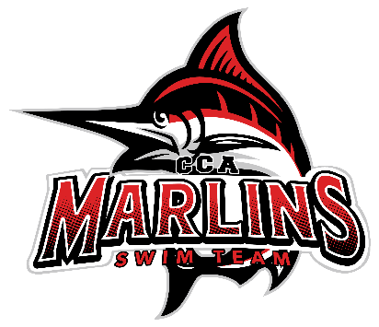

Marlins Board Meeting Minutes Recap (9/25/25)
Note: Date changed from September 23 due to conflicting availability.
Attendance: Brooke, Julie, Whitney, Coach Susan, Juliet, Coach Buffy
1. Finances
- Julie: Sent out recent expenses; the budget is slightly off due to funds set aside for a new coach, but all accounts are looking good.
- Confirmed sponsorships from Roanoke Valley ENT, Allegery, ClinicalStrat, Rhino Financial, and National Pools.
- Raised $339 at the Back to Pool meet from concessions and merchandise.
2. Swim-a-thon Discussion
- Scheduled for November 1; times to be determined (TBD).
- Susan is setting up the USA Swimming component and will work with Ginger Avis.
- Brooke is connecting with Carrie W. regarding the Team Unify portion, who will work alongside Amanda Foutz.
- Buffy plans to collaborate with Amina on times and food arrangements and will also coordinate with Amanda on this.
3. Coaching Updates
- Coach Buffy: Reports that the Silver group is doing well, although this year has been challenging due to new swimmers and coaching dynamics. Gold group is going well also. Coach Miranda is providing significant support and giving swimmers valuable feedback. Discussed coaching rotations and availabilities.
- Coach Susan: Positive feedback on Mini Marlins; both groups are small but thriving. This is the first time running both groups on two days, and it’s going well.
- Lancer Lot has three groups:
- Coach Morgan S. coaches the Junior Black group.
- Coach Kevin's group is performing well.
- Coach Kieran McAllister is doing a great job with his group.
- Coach Susan’s groups are successful; offering swim lessons on Tuesday and Wednesday for 18 kids with four instructors.
4. Recap of Back to Pool Meet
- The meet went well; while a couple of areas could be improved, the overall execution was smooth. Hospitality was well managed, and the Clerk of Course operated efficiently.
5. Short Course Meet Schedule
- The schedule is set with no anticipated changes.
6. Anything Else
- Coach Search Committee Update: Six applicants have applied so far, with one invited interview. The job posting went live on 9/23/25, and the committee is beginning the first round of interviews in the next couple of weeks.
- Discussion of potential ideas for a Masters coach.
Next Meeting: Scheduled for October 21, 2025, at 8:30 PM (virtual).

